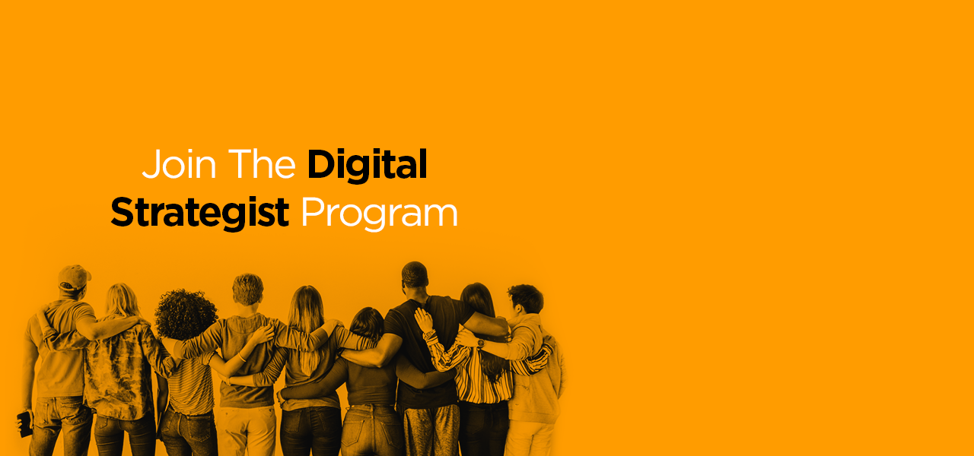
COPY ASSIGNMENT:
Write a short and witty creative and associate copy. Below is the brief-
Brief: Body grooming is essential yet a lot of men refuse to groom their body. Research says, women like men who groom better and are less likely to date men with body hair.
Create alternate copies for the following creatives without losing the essence of the brief or the tonality.
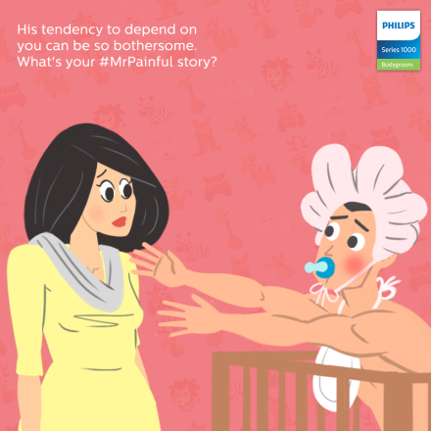
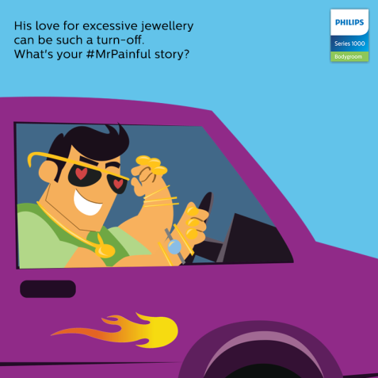
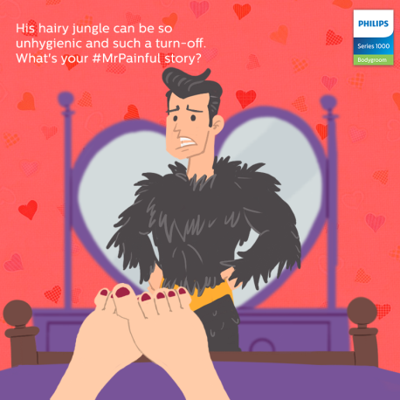

DESIGN ASSIGNMENT

Create a Static post for Whirlpool Bloomwash washing machine (saves 2 buckets of water with every wash) on the account of #WorldWaterDay. Below is the copy

“No two planets? Better save two buckets. #WorldWaterDay”

The creative should be eye-catching, must deliver a clear message and should follow brand guidelines. Below is the Instagram link of Whirlpool Nepal for your reference-
https://www.instagram.com/whirlpoolnepalofficial/

